AGENDA
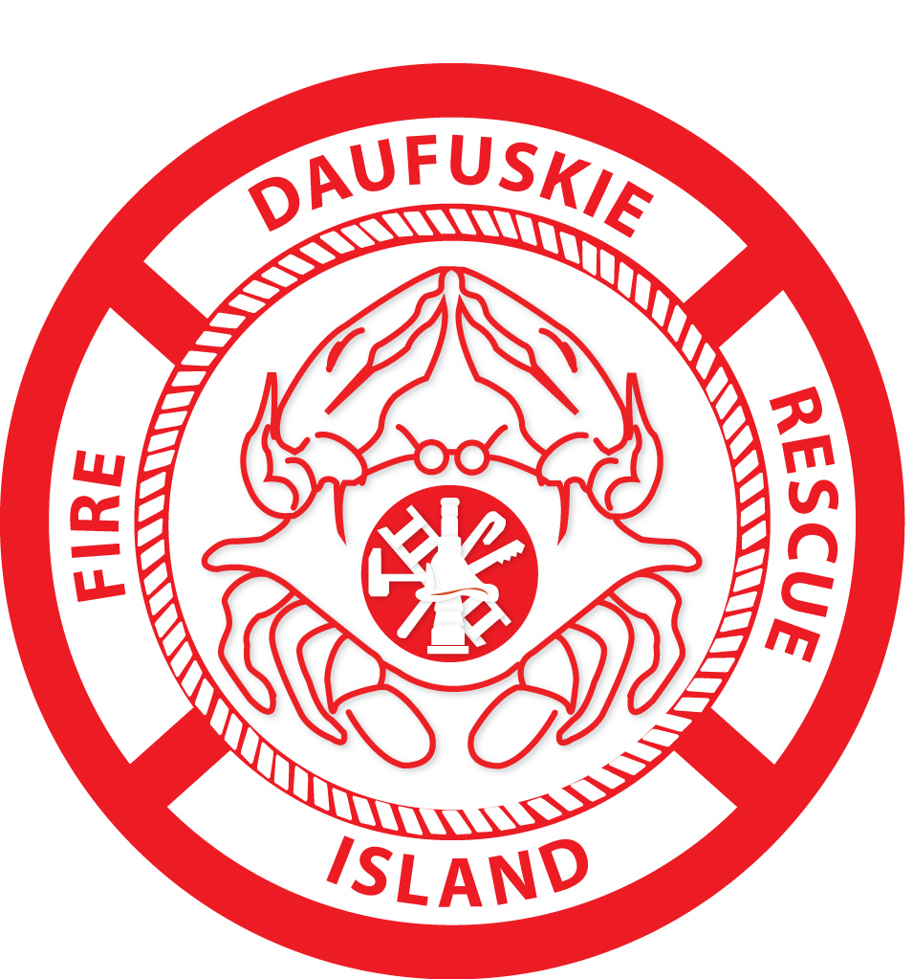
DAUFUSKIE ISLAND FIRE DISTRICT
BOARD MEETING
Wednesday, January 17, 2018
4:00 PM.
400 Haig Point Road

1. CALL TO ORDER

2. MINUTES OF THE NOVEMBER 15, 2017 AND DECEMBER 9, 2017 COMMISIONERS’ MEETINGS – REVIEW AND APPROVAL

3. CITIZENS COMMENT PERIOD

4. DECEMBER’17 FINANCIAL REPORT – REVIEW & APPROVAL

5. DAUFUSKIE ISLAND UNFIT STRUCTURES – REVIEW AND DISCUSSION

6. KITCHEN CABINETRY-UPDATE

7. COMMUNITY INVOLVEMENT

8. FEMA GRANT-STATUS

9. NEXT COMMISSIONERS’ MEETING – MARCH 21, 2018

10. ADJOURNMENT

